**Monitoring & Evaluation Plan**

**{**The project: on the Cambodia Consortium for out-of-school children**}**

**{Cambodia}**

*Version [N°] completed on [DATE] by [NAME/LAST NAME].*

*The project's M&E plan is in line with the framework set by Action Education's international direction, and in particular with the MEAL policy and international norms and standards such as CHS, OECD DAC criteria and SPHERE standards.*

*This document must be completed for ALL projects. For all stages, the key lies in the collective reflection process. You need to organize an inclusive process and choose participatory methods to complete this document.*

*Monitoring and evaluation has a cost. That's why we recommend setting aside at least 3% of project costs for the Monitoring & Evaluation System.*

*Modification rules: The M&E plan is a living document that can be updated throughout the project cycle. Each modification to the M&E plan must be documented and shared with all relevant project stakeholders. The document version is updated on the cover page.*

Table of contents

**Table of contents**

**1. Project features 4**

1.1 Project description 4

1.2 M&E system objectives 4

1.3 Information needs of project M&E stakeholders 4

**2. Resources available for project M&E 5**

2.1 M&E financial resources 5

2.2 M&E human resources 5

2.2.1 ACTEI team 6

2.2.2 Operational partners involved 6

2.2.3 Diagnosis of capacity-building needs 6

2.2.4 Capacity building planning 6

2.3 Organization of the steering committee provided for 7

**3. Description of the M&E System 7**

3.1 Monitoring scope 7

3.2 Scope of evaluation 8

3.3 Description of monitoring action plan 9

3.3.1 Monitoring requirements of institutional or private lessors : 9

3.3.2 Main stages and roles and responsibilities 9

3.4 Description of evaluation action plan 10

3.4.1 Evaluation requirements of institutional and/or private backers : 10

3.4.2 Main stages and roles and responsibilities 10

# Project features

## Project description

CCOSC Phase II focusses on 1) equitable access, 2) quality and relevance, and 3) ownership and accountability. OOSC must be initially identified through participatory community mapping campaigns to bring them into the formal education system through supply and demand side interventions. While notable gains have been made during Phase I in access, it is critical that these efforts be expanded to reduce push and pull factors and other barriers to access. Thus, the first access of Phase II will concentrate on the axis of equity of access. In line with the local and global drive to make education more meaningful and relevant, the second axis focuses on quality. The intervention here directly responds to Consortium research that both children and their parents do not find sufficient value in schooling27. In order to ensure completion of a full course of primary education, quality and relevance will be critical to retaining students once they are enrolled. Lastly, as part of the sustainability strategy for Phase II, CCOSC will promote strengthened accountability between duty bearers and rights holders to primary education. These key actors include: local authorities, district education officials, parents, youth, and community members. Thus, the third axis focuses on accountability and ownership in order to ensure the sustainability of Phase II efforts to enrol and retain the most marginalised children. CCOSC Phase II will intervene in approximately 2,694 schools across Cambodia according to the expertise and local involvement of each partner. As noted in Tables 3.3 and 3.4, the Consortium will adopt a tailored approach suited to the needs of local communities. As such, there will be certain interventions that take place in all provinces across the Consortium, and others which only take place in selected provinces. School infrastructure, in-kind support, curricula revision, capacity development for teachers and education actors, enrolment campaigns, parent and youth advocacy, best practices, policy dialogues, and research and documentation will take place in all provinces (or at national level, where appropriate). For select provinces, nonformal education, flexible classes, scholarships for learning, livelihood

4 .2 Result Framework

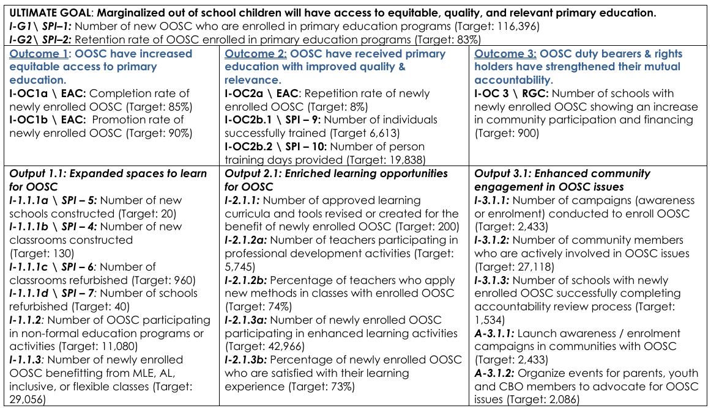

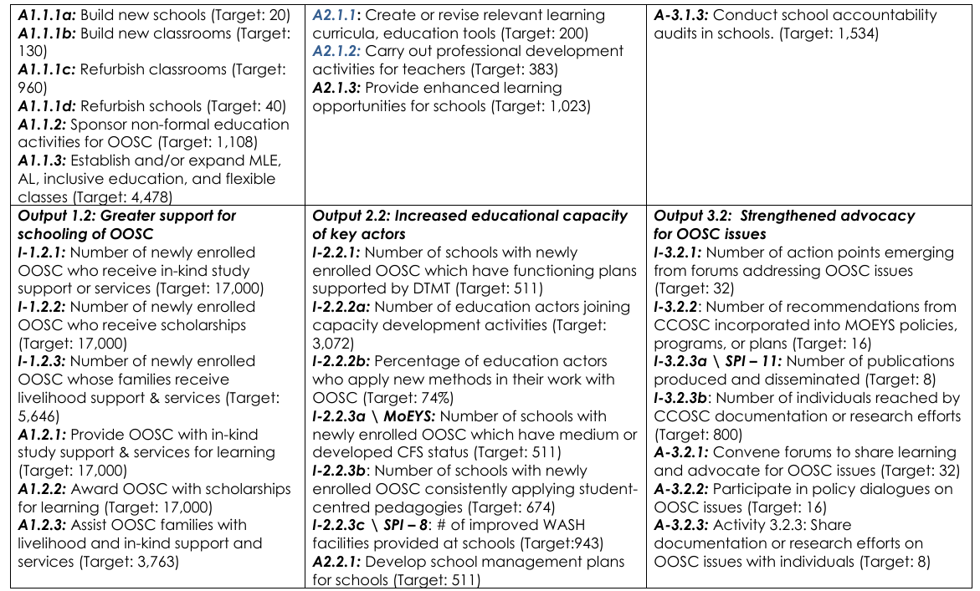

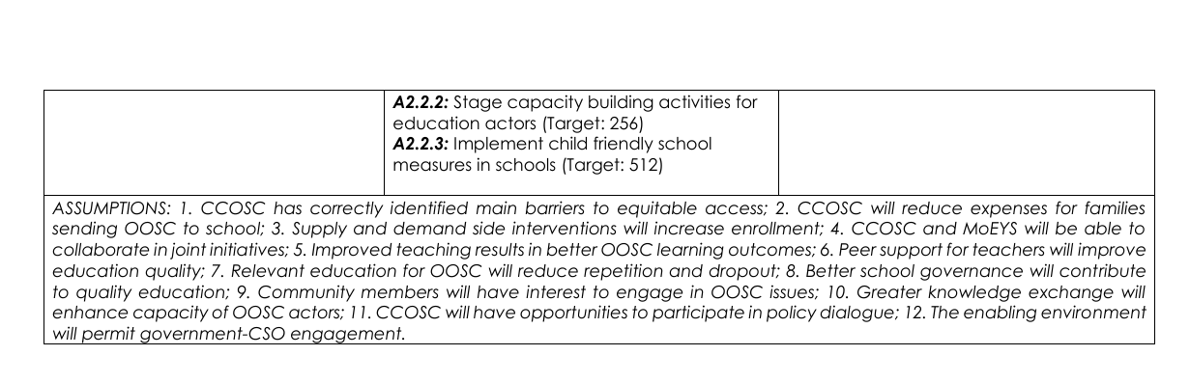

## M&E system objectives

*Recall the overall objectives of the project's M&E system for all stakeholders, highlighting the links between monitoring and evaluation.*

| **Purposes of an M&E System in general** | **M&E objectives defined for the project** |
| --- | --- |
| Improving management and efficiency | Ensure timely, cost-effective, and coordinated implementation of project activities |
| A common understanding shared by all stakeholders | *Foster alignment on goals, roles, and outcomes* |
| Reporting and communication | *Ensure transparent, timely, and actionable reporting* |
| Capitalize and learn | *Capture lessons learned and best practices for future programming* |

## Information needs of the project M&E stakeholders

*Specifying the information needs of all project partners helps to ensure the relevance of the data collected for project monitoring and evaluation. The table below presents three categories of recipients: (Steering bodies, Institutional players, Implementation partners).*

*Source: Workshop/exchanges with project stakeholders - project budgeted operational planning meeting and presentation of M&E plan*

| Types of stakeholders in your project | Project expectations | M&E  expectations | Source of information *(reports, dashboards, meetings, etc.)* |
| --- | --- | --- | --- |
| **Donor** |  | Provides the overall picture of the impact generated by their investment  Helps donors in decision to pursue further funding with CCOSC | Semester Progress Report  Semester Financial Report |
| **AEA Management team** |  | Track project progress against objectives  Alert on course correction where necessary  Inform program funding decisions  Assist with overall program performance, learning and accountability | CP Snapshots  Quarterly financial & narrative reports from CPs  CEMIS  Ad hoc research  Case study |
| **AEA Program team** |  | Efficient program/project implementation  Assist with report preparation for donors  Measure effectiveness and efficiency of CCOC  Sustainability and accountability in program implementation | CP Snapshots  Quarterly financial & narrative reports from CPs  CEMIS |
| **AEA Finance team** |  | Ensure transparency of fund utilization  Facilitate audit activities  Effective fund management  Assist with financial report to donors | Financial reports  Audit reports  CP budgets  Online financial management system  Supporting documents. |
| **CP program teams** |  | Support effective, efficient implementation  Contribute to effective program management  Aid with timely problem solving and decision making  Improve on training provided based on perceived quality | CEMIS  Field Monitoring Report  Snapshots  Quarterly briefs  Ad hoc surveys  Evaluation of teacher training |
| **Direct beneficiaries** |  | Participation in monitoring processes  Decision making and accountability to beneficiaries  Participatory planning to ensure inclusion of voice | Evaluation and assessment  reports, training reports,  mapping reports, project  information, consultation process. |

*.*

# Resources available for project M&E

## M&E financial resources

*Insert validated M&E budget or M&E-related budget lines or specify, if relevant, the planned budget (as a % of the overall budget) for M&E activities, deployment in terms of HR, equipment and capacity building.*

*Support: project budget.*

*Examples of M&E costs: human resources costs (allocated time and training); technical & support costs (tablet, software, paper, printing...); travel costs for information gathering; focus group organization costs; translator costs; per diem for resource persons; collective workshop costs....*

**Cost and feasibility table**

| Activities | How it works | Unit | Quantity | CU | Amount |
| --- | --- | --- | --- | --- | --- |
| **START-UP PHASE** | | | | | |
| Acquire equipment/software... |  |  |  |  |  |
| Training device users |  |  |  |  |  |
| Develop implementation/parameterization tools |  |  |  |  |  |
| Baseline study |  |  |  |  |  |
| **IMPLEMENTATION PHASE** | | | | | |
| Data collection (throughout the project) |  |  |  |  |  |
| Data compilation / Dashboard update |  |  |  |  |  |
| Data analysis |  |  |  |  |  |
| Use of data (reporting, advocacy, communication, etc.) |  |  |  |  |  |
| Feedback to stakeholders |  |  |  |  |  |
| Mid-term evaluation |  |  |  |  |  |
| **TRANSITION & CLOSING PHASE** | | | | | |
| Final project evaluation |  |  |  |  |  |
| Report and final information |  |  |  |  |  |

*Complete the activities and add as many lines as necessary according to your project and context.*

* The budget allocated to MEAL depends on the size and complexity of the project or program. In general, it is recommended to allocate between 5% and 10% of the total project budget. This percentage covers the costs of data collection, analysis, reporting and continuous process improvement. But many of the monitoring and supervision activities carried out in the field by school management committees, communes and technical services that are charged to operations should be well planned to contribute to MEAL without being charged to the budget (Source: MEAL Policy )

*Noted: we don’t have budget know detail for M&E implementation

## M&E human resources

Identify the people to be made responsible. Record the human resources allocated to the project (at headquarters and in the field) for the various phases of the project. M&E organization chart if relevant. Specify the roles and responsibilities of the teams in charge of the system. In the case of a consortium, specify if there are any specific roles and responsibilities for the lead and how it works with the implementing partners.

*\*\**The CCOSC MEALi team is headed by the **MEALi Manager** who reports directly to the MEALi Director within AEA. At the local level, each CP has an M&E project officer dedicated at least 50% to the project. All project officers and M&E focal points will be trained in CEMIS as well as all M&E guidelines, processes, and tools. Each regional lead organization (RLO) also has one M&E focal point *(one per region)* who are fully dedicated to the project. The **regional M&E focal points** have the following roles: 1) supervise the quality of data collected in their regions, 2) feedback to the implementing partner M&E officers where necessary, 3) identify any gaps in the data, 4) provide technical support as and where necessary. In addition, there are **2 M&E officers**, and **2 database officers** based in AEA who will be responsible for quality checks of the M&E data collected.

### 2.2.1 ACTEI team

*What human resources are available within the ACTEI team: project manager, M&E officer if available, facilitator or other person who can contribute to data collection... Write down in a few lines, or bullet point format, the people in the team who are available and mobilized for M&E.*

* **M&E Officer** *(if available)*: Leads data collection, analysis, and reporting; ensures quality and consistency of M&E processes.
* **Project Manager**: Oversees implementation and ensures M&E activities align with project goals and timelines

### 2.2.2 Operational partners involved

What human resources are available from partners to implement M&E? Write down in a few lines, or bullet point format, the people on the partners' teams who are available and mobilized for M&E.

Partner 1: World Vision Cambodia

M**& E Specialist**

- Overall monitor data management, data enttry, data cleaning, check list both CEMIS and Tracking tools

- Conduct field monitoring to target provinces and consolidate reported data

- Support any extra requirement or question from project side.

- Support manager to produce quarterly and semester report using data from field, CEMIS and other relative data

- Ensure sufficient child supporting documents, evident, tracking tools and distribution document stored

- Provide guidance to program and technical team on M&E framwork to ensure alignment of project implemenation

Partner 2: Ponleur Kumar

M&E Coordinator:

Oversea the CCOSC project including the M&E to ensure that all the agreed outputs and main activities are met and accurate.

Partner 3: Caritas Cambodia

PME Officer :

- Overall monitor data management, data entry, data cleaning, checklists list both CEMIS and Tracking tools

- Conduct field monitoring to target provinces and consolidate reported data

- Support any extra requirement or questions from the project side.

### 2.2.3 Diagnosis of capacity-building needs

*Analyze the needs of the project teams involved, both within ACTEI and with partners: understanding M&E, data collection, data analysis, use of data, use of tools (excel, method...).*

Examples: experienced team members, excel expertise and skills, data collection skills....

Junior profile, need for capacity building in......

* At least 2 years of experience in the design and implementation of M&E in development projects implemented Page 3 of 5 by national/international NGOs/UN bodies/ Government/private sector.
* Experience in planning and managing surveys, developing and refining data collection tools, and with data quality assessments and oversight.
* Strong experience in conducting field monitoring to oversee projects activities.
* Strong information management and telecommunication skills and proficiency in IT/computer skills (including sound advanced MS Excel, MS PowerPoint and MS Word proficiency), Google drive/Google Sheets, online collaborative applications and other software for data analytics Experience in designing tools and processes/methods for data collection and data quality assurance. Strong experience in conducting field visits for spot check, data validation and to monitor the quality and completeness of data sets. Comfort working with qualitative and quantitative methodologies for data collection and analysis.

**Source: DJ :Monitoring, Evaluation, Accountability and Learning (MEAL) Officer (AEA Cambodia)

### 2.2.4 Capacity building planning

*Complete the table below to plan any capacity-building actions.*

| Subject of capacity building | Pedagogical objectives | For whom (target audience) | By whom (internally, externally, etc.)? | When? | Course duration |
| --- | --- | --- | --- | --- | --- |
| Link to CEMIS | This is the CEMIS system which all partners will access and update on a regular basis |  | Internally |  |  |
| CCOSC Quarterly Briefs (internal) | Quarterly briefs are compiled internally for AEA and Consortium management to review |  | Internally |  |  |
| CCOSC Semester Reports (donor) | Semester reports are assembled from the quarterly briefs, and are intended for the Board, Advisory Committee, and Donor review |  | Internally |  |  |
| CCOSC Quarterly newsletter | CCOSC communications team will develop a quarterly newsletter highlighting interesting case studies and innovative practices (TBC) |  | Internally |  |  |

| Education policy & advocacy efforts | Relevant education policy pertinent to CCOSC will be published on OHL, together with records of CCOSC advocacy to influence the implementation of these policies |  | Internally |  |  |
| --- | --- | --- | --- | --- | --- |

| All CCOSC research | Any research reports commissioned by CCOCS or carried out by CPs, including the baseline and endline surveys, will be published. |  | Internally |  |  |
| --- | --- | --- | --- | --- | --- |
| All CCOSC monitoring tools | All the monitoring tools included in this guide, as well as other templates to be developed by the M&E manager, will be stored on the OLH |  | Internally |  |  |
| All CCOSC financial monitoring tools | All financial reporting templates, including budget formats and guidelines, will be made available to CPs |  | Internally |  |  |
| All CCOSC guidelines, tools, and curricula (AL, IE, MLE) | Standards, curricula, tools, and other technical documentation developed by the Consortium Expertise Team (CET) will be housed on the OLH |  | Internally |  |  |
| All CCOSC training manuals for capacity building efforts | All documents or capacity building materials from the CET will be stored here, for CPs to access and enhance their own professional development |  | Internally |  |  |
| Link to CCOSC social media platform | All communications platforms (i.e. social media) managed by CCOSC will be linked to the OLH |  | Internally |  |  |
| All CCOSC press releases and media information | All press releases, media information, publicity campaigns, or other public relations documentation will be available on the OLH |  | Internally |  |  |

## Organization of the steering committee planned in the project document

*Analyze the project management organization and determine its consistency with the M&E management system. Draw up an organization chart.*

*Source: Workshop/exchanges with project stakeholders. - Project budgeted operational planning meeting and presentation of ME plan*

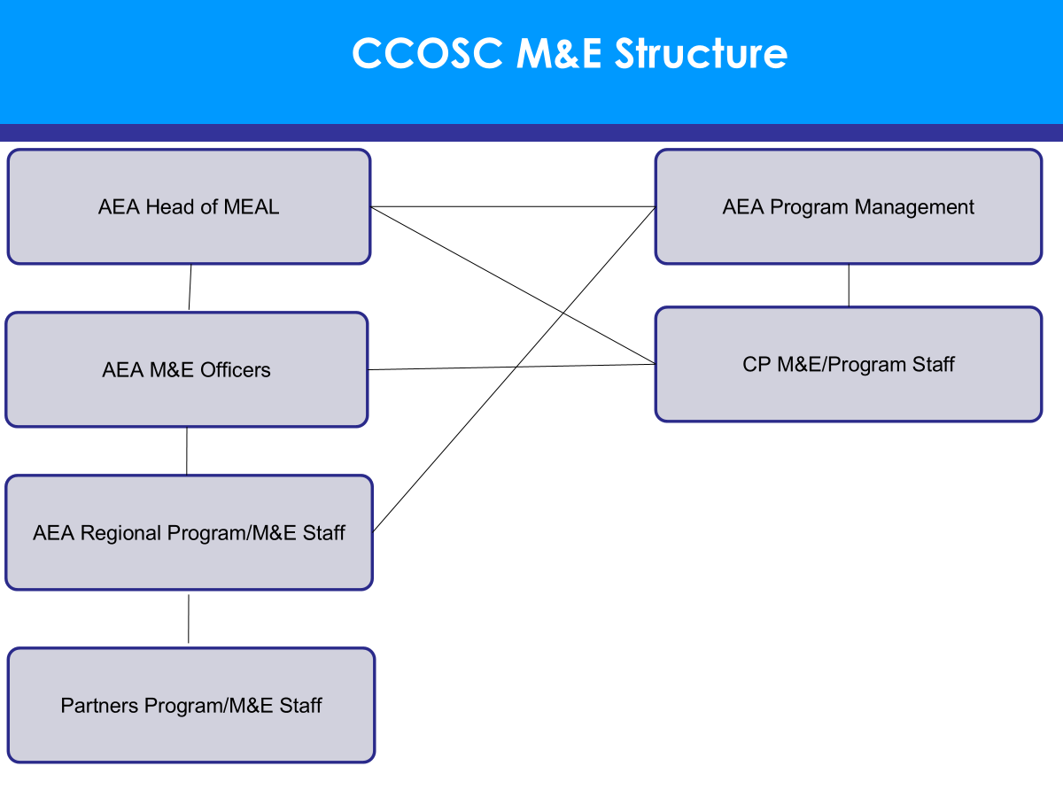

Source : Présentation of CCOSC M&E Structure

# Description of the M&E System

## Monitoring scope

*Determining the purpose and scope of M&E is an exercise in which stakeholders answer the following questions: What are the results and objectives to be monitored (cf. logical framework)/ What questions will M&E need to answer?/ What intermediate results will M&E need to address? What are the indicators, signals or progress markers?*

| **Follow-up questions and "intermediate results”** |
| --- |
| *Steering questions* |
| Are activities progressing according to plan? Are targets being met? ..... |
| **i). Data generation** |
| **ii). Snapshots** |
| **iii). Ongoing CP – RLO meetings** |
| (Source : Guide for CCOSC 2021 V4,Page :7) |
| *Quality of activities and services* |
| **i). Data generation** |
| Lessons learned from Phase I of CCOSC demonstrated the need for greater quality assurance at multiple levels of Consortium implementation. Therefore in Phase II QA will operate on the following levels:  1- OOSC data verification at CP level (Process, Method, and Tool)  All M&E focal points will be required to have an additional verification of data before inputting into the system. This will function as follows:   1. Hard copy data will be collected by the project officer or equivalent (responsible for implementing the activity) 2. This hard copy data will be input into CEMIS (see below) by the M&E focal point. 3. This soft copy data in CEMIS will be cross-checked by the project officer or equivalent named in paragraph a above. |
| 2- OOSC data verification at RLO Level (Process, Method, and Tool)  All regional focal points will have the responsibility to ensure the integrity of data by partners in their region. This will operate as follows:   1. Regional M&E focal points will ensure that CP M&E focal points have the technical ability to enter data into the system correctly. 2. Regional M&E focal points will spot check data by asking for hard copy records for certain partners on a random basis. 3. If any errors are detected from the process in paragraph b above, regional M&E focal points will undergo a comprehensive data check of all partner data. |
| 3- OOSC data verification at AEA MEALi Team Level (Process, Method, and Tool)  Data integrity verification and systems maintenance will happen at the AEA level. This will function similarly to #2 above, with AEA spot checking certain regional focal point M&E data for accuracy and integrity. TO this end, a quality data assurance tool will be developed to focus on: 1) OOSC identification process, 2) OOSC criteria / definition, and 3) proper supporting documentation. AEA M&E officers from HQ will carry out these checks.  In addition, AEA will be responsible for ensuring ongoing maintenance and upgrade of the CEMIS system. |
| **ii). Snapshots** |
| A snapshot is one of the key monitoring tools for CCOSC. It is a summary capturing the progress of partner activities at the learning sites. Consortium partners will complete partner snapshots on a monthly basis and upload the results to CEMIS on a monthly basis. These snapshots will include the following: 1) a summary of activities conducted, 2) key contributions towards outputs and outcomes, 3) key lessons learned, 4) innovative aspects of project implementation, 5) areas of concern for escalation to regional level, and 6) PMP indicator data *to* be entered into CEMIS. The template for this snapshot can be found at Snapshot. |
| **iii). Ongoing CP – RLO meetings** |
| RLOs will hold quarterly meetings with their CPs in the region. The purpose of these meetings will be to review progress against expected deliverables, address any emerging issues or challenges for forwarding to the Board, to support with M&E and in particular report writing. Lessons learned from the snapshots can be used to give feedback to CPs on potential areas for improvement.  *Source from : PMEAL Guide for CCOSC 2021* |
|  |
|  |
|  |
|  |
|  |
| Stakeholder satisfaction questions |
| 1. Percentage of newly enrolled OOSC who are satisfied with their learning experience |
| "Satisfied with their learning experience" will be assessed according to a number of criteria: 1) opinion about the quality of education, 2) level of interest or excitement in studying, 3) commitment to future studying, and 4) understanding of the importance of education for them. This is a pilot indicator. |
| *Data sources for collecting data by: Survey/FGD with OOSC |
| Key responsibility for collect data have such as : POs collect , M&E focal points check, M&E Coordinator analyses |
| For Target for LOP is 73% ,by the year ,Y1 :70% ,Y2 :72% ,Y3 :74%,Y4 :75% from the Survey/FGD with OOSC. |
| 2.Number of schools with newly enrolled OOSC which have medium or developed CFS status |
| CFS" = as defined by the child friendly policy of MOEYS concerning the six dimensions of: 1) inclusivity, 2) effective learning, 3) health, safety and protection, 4) gender responsiveness, 5) participation of CMs, and 6) support from DTMT; "medium or developed" CFS status means 3-5 of these dimensions are 'satisfactory' as per the UNICEF CFS checklist for Cambodia (endorsed by MoEYS) . |
| (Source from : Proposal_CCOSC, Page :69) |
| 3.Number of improved W.A.S.H. facilities provided at schools |
| This indicator tracks the Number of W.A.S.H. improvements made in schools by the Consortium intervention. W.A.S.H. improvements include: 1) improved basic sanitation facilitateis, 2) improved drinking water facilities, or 3) improved hygiene at schools. The definition and calculation methods for this indicator follow the "List of Standard Performance Indicators" from EAC dated October 2017. |
| (Source : Proposal II_CCOSC ,page :70) |
|  |
|  |
|  |
|  |
|  |
|  |
|  |
|  |
|  |
|  |
|  |
|  |
|  |
|  |
|  |
|  |
|  |

*Complete the table and formulate your own questions, adding as many lines and types of questions as you need.*

## Evaluation scope

*Determining the purpose and scope of the evaluation is an exercise in which stakeholders answer the following questions: What are the results and objectives to be evaluated (cf. logical framework)/ What questions will the evaluation need to answer?/ What intermediate results will the evaluation need to address?*

*Questions can be organized according to evaluation criteria: OECD criteria: coherence, relevance, effectiveness, efficiency, impact, sustainability, etc.*

*Other evaluation criteria: partnership relations, participatory approach, cooperation, empowerment/appropriation....*

| Mid-term evaluation questions (if relevant) |
| --- |
| Criteria |
| N/A |
|  |
|  |

| Final evaluation questions |
| --- |
| Criteria |
| Evaluation of CCOSC will take place through 1) annual reviews, 2) baseline and endline surveys, 3) external (midterm and final) evaluations, and 4) longitudinal case study, each of which is addressed below. These evaluation processes are designed to answer the big picture question of how CCOSC is performing, and to assess the top level impact indicators in the PMP. In summary, reviews and evaluations will look at questions of relevance, effectiveness, efficiency, impact, and sustainability. The key research questions will be as follows:   * What has been achieved? How do we know that the project caused the results? * What difference has the project made? Can the impact be improved? * Are the objectives being met? Is the project doing what the plans said it would do? * Is the project being well-managed at CP and RLO and Consortium level? * Where does the project need improvement and how can it be done? * What is the relevance of OOSC activities to the needs of OOSC? * How effective are the activities of CP to contribute to the intended results? * How well are donor resources being used within CCOC * How likely are the results or impacts to be sustainable after CCOSC closes  Annual Review CCOSC plans to conduct annual reviews of CCOSC. These annual reviews will be conducted under the supervision of the AEA M&E Manager together with regional focal points. The purpose of these annual reviews will be to gather data or inputs to be used for course correction, reflection, impact assessment, and learning. The outcomes of this exercise will be shared during the Annual Partner Reflection (APR) and will also be shared with the Consortium Board and the Advisory Committee. Baseline and Endline Surveys CCOSC will also conduct a baseline survey as well as an endline survey. The purpose of these surveys will be to establish initial and concluding values for key indicators. These surveys will be carried out in collaboration with implementing partners and under the supervision of the AEA M&E Manager overseeing a team of independent consultants. RLOs and CPs, in particular the M&E focal points, will be asked to cooperate with and facilitate these external teams to assist them in gathering the required data needed to complete the surveys. Evaluation (mid-term and final) CCOSC will also contract mid-term and final evaluations to be carried out by an independent, external evaluation firm. The goal of these evaluations will be to assess the relevance, effectiveness, efficiency, impact, and sustainability of the Consortium and to assess how well Phase II has built on the recommendations and lessons learned from Phase I. As with above, RLOs and CPs, in particular the M&E focal points, will be asked to cooperate with and facilitate these external teams to assist them in gathering the required data needed to complete the surveys. Longitudinal case study The theory of change for CCOSC is that project activities will be able to reduce the push and pull factors that prevent children from completing a full course of basic education. Changing knowledge, attitudes, skills, and habits (K.A.S.H.) will be key to the success of the project. Moreover, MEALi methods will need to have the ability to assess quality of as well as access to education. The perceptions, beliefs, and opinions of key education actors within CCOSC will be crucial to driving positive change. In order to assess changes in KASH, as well as perceptions of quality, a longitudinal case study will be carried out to evaluate the extent to which CCOSC activities have effected positive change as intended. The case study will be limited to a small sample of schools and will aim to assess the performance in a number of key focus areas: 1) student attendance levels, 2) teachers’ perceptions on quality of activities, and 3) attitudes and practices among parents with regard to engagement in their children's education. How we remain accountable These key lessons learned, and findings will also be shared with communities during focus groups / discussion forums to facilitate a participatory implementation process. The key method of accountability will be field visits, during which the AEA program and M&E staff, together with CPs, will engage with beneficiaries in inclusive discussions to assess the progress and utility of CCOSC activities. The purpose of these field visits is to:   * To ensure the partners do not work in isolation and that RLOs are effective in ensuring a shared approach to Consortium knowledge and resources * To ensure efficient cooperation between the Consortium Expertise Team and the CPs in the field * To monitor physical and financial progress so that decisions can be made about spending and resource distribution to achieve the aims of CCOSC * To compare activities achieved against targets, assess effectiveness of methods and strategies, and monitor distribution of project benefits * To assess the views of key stakeholders including beneficiaries (i.e. students, parents, children) regarding the services being provided by CPs under CCOSC. * To determine the impact on the target population, especially on quality of life and living standards as a direct result of CCOSC * To study specific implementation problems, constraints, obstacles, gaps, etc., and practical solutions recommended by CPs for their planning * To assess the potential of activities to contribute towards behavior change.   (Source : PMEAL Guide for CCOSC 2021) |
|  |
|  |

*Complete the table and formulate your own questions, adding as many lines and types of questions as you need.*

## Description of monitoring action plan

### 3.3.1 Monitoring requirements of institutional or private donors:

*Integrate donor requirements in terms of reporting and monitoring activities (reporting date/period/donor indicator requirements, data disaggregation requirements, etc.).*

* EAC «  Approve reports »

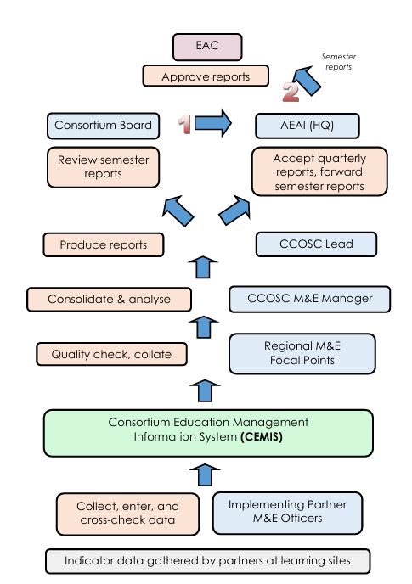

* Monitoring activity

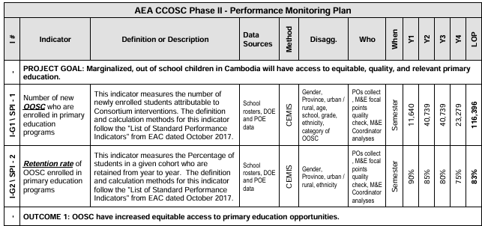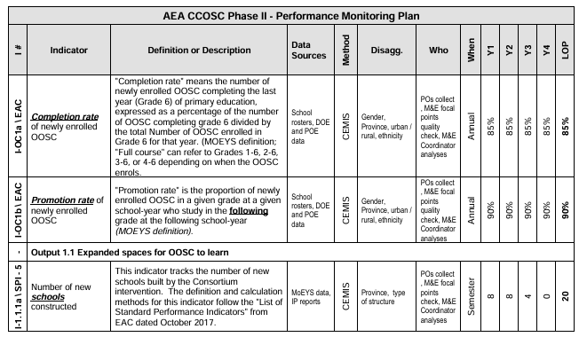

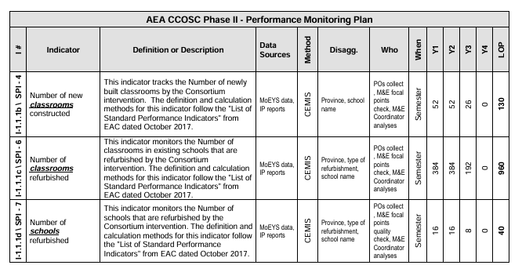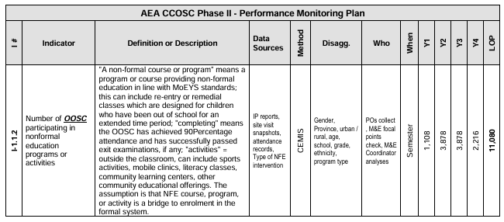

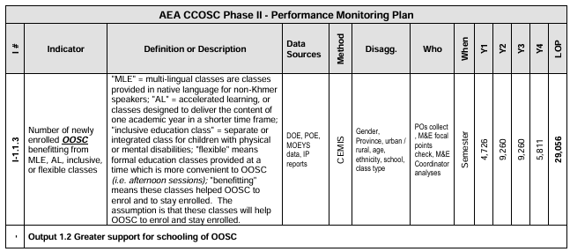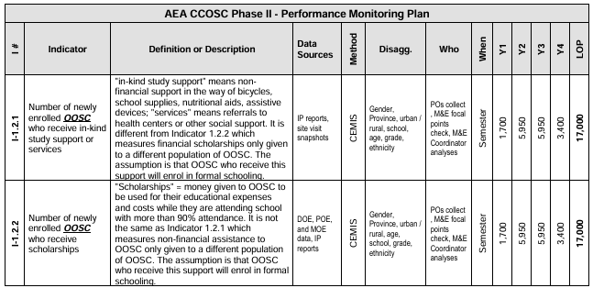

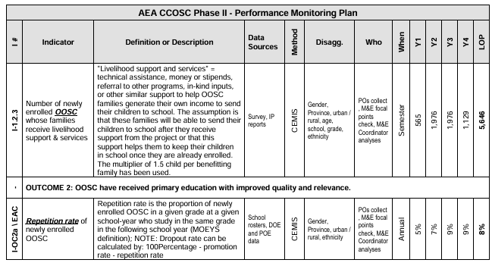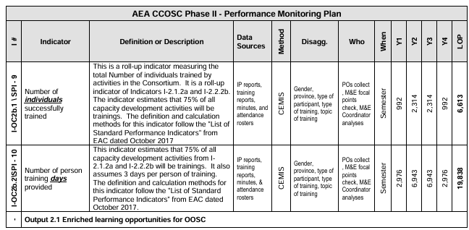

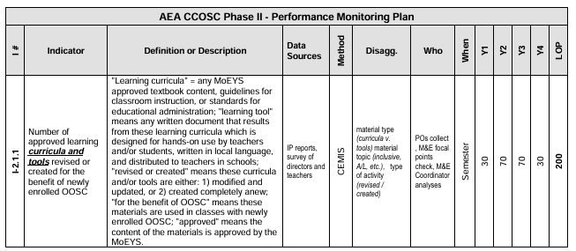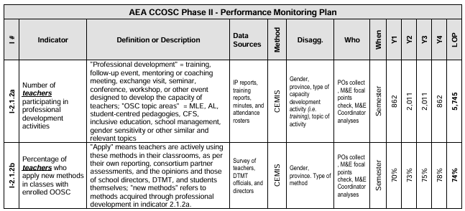

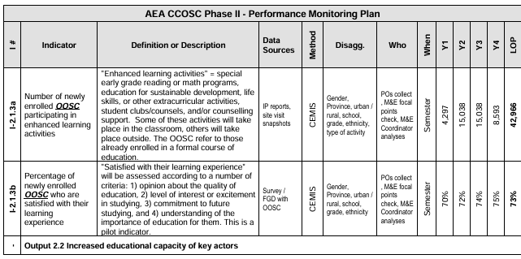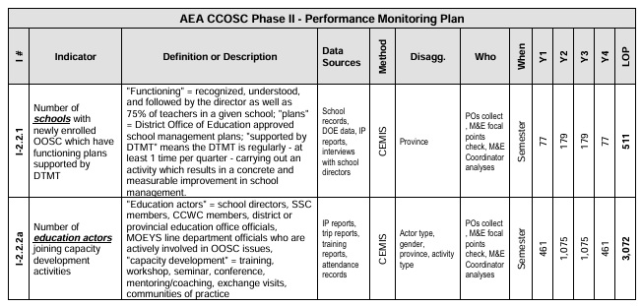

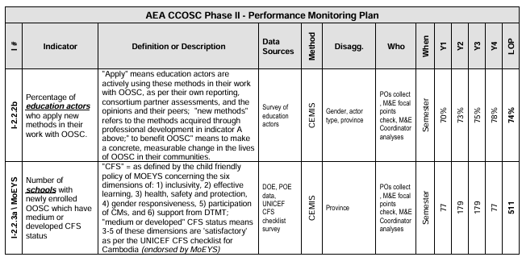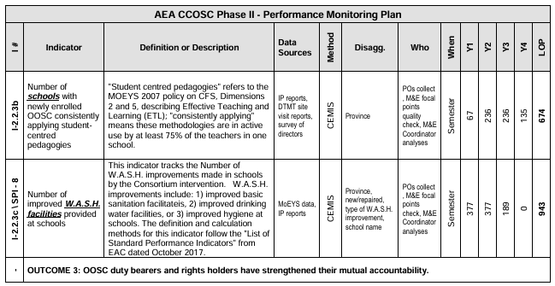

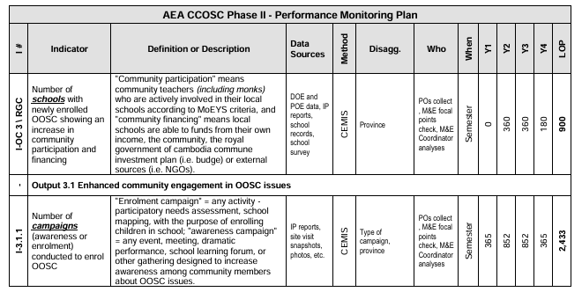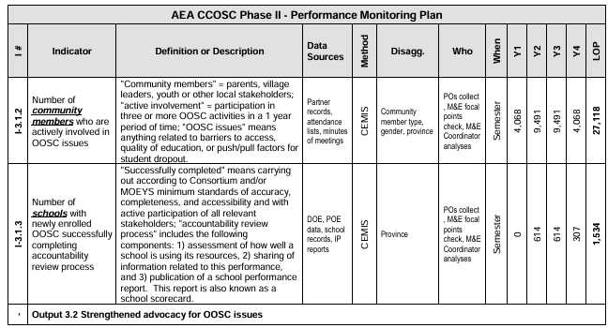

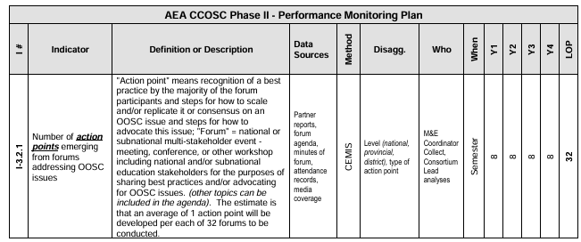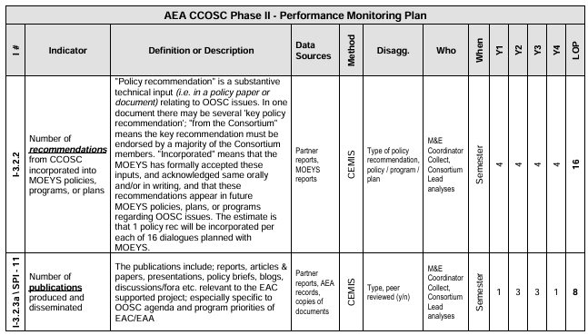

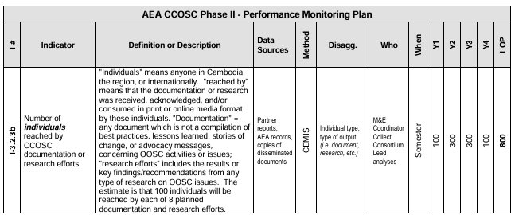

### 3.3.2 Main stages and roles and responsibilities

*Recall the various monitoring activities planned for project monitoring and steering, and the use of data collected through the various monitoring tools.*

Question guide for completing the table below :

* When are the data collection tools scheduled to be developed?
* If not, when do we need to carry out the study for the reference situation?
* when to collect data and when to analyze it
* To answer this question, a schedule needs to be drawn up. The easiest way is to think in retrospect ("retroplanning"), starting from the date when the analyzed data will be used.

| Stages / Activities | RACI | | | | Period | Products/  deliverables |
| --- | --- | --- | --- | --- | --- | --- |
| *The steps listed here are indicative (based on the M&E steps) and should be adapted to your own specific needs and activities.* | Responsible | Accountable | Consulted | Informed |  |  |
| **START-UP PHASE** | | | | | |  |
| Acquire equipment/software... | Consultance | Consortium Lead | Consortium partners | Regional Leads | 6 Months |  |
| Training device users | Consortium M&E Manager | Consortium Lead | Consortium partners | Regional Leads | 4 days |  |
| Develop implementation/parameterization tools | Consultance/Consortium M&E Manager | Consortium Lead | Consortium partners |  | 1 Forum/year |  |
| Baseline study | Consultance | Consortium Lead | Regional Leads |  | 2 months |  |
| **IMPLEMENTATION PHASE** | | | | | |  |
| Data collection (throughout the project) | Consortium partners | M&E Manager | Regional Leads |  | 2 Semester/Year |  |
| Data compilation / Dashboard update | Consortium M&E Manager | Consortium Lead | Manager programmer/ | Regional Leads | Regional Leads |  |
| Data analysis | MEAL manager | Consortium Lead |  |  |  |  |
| Use of data (reporting, advocacy, communication, etc.) | Consortium Lead |  |  |  |  |  |
| Feedback to stakeholders |  |  |  |  |  |  |
| **TRANSITION & CLOSING PHASE** | | | | | |  |
| M&E evaluation | Consultance | Consortium Lead | Donor/ | Regional Leads | 3 months |  |

*Complete the table and formulate your own activities, adding as many lines and types of questions as you need.*

## Description of evaluation action plan

### 3.4.1 Evaluation requirements of institutional and/or private donors:

*Integrate donor requirements in terms of evaluation: mid-term evaluation, final evaluation, deadline for final evaluation, external evaluation, mandatory evaluation criteria.....*

***In terms of evaluation, midterm and final evaluations will be contracted by the Consortium Lead and carried out by an independent, external evaluation firm. The goal of these evaluations will be to assess the impact and sustainability of the intervention.***

*-We will conduct the baseline, mideline and endline evaluation with a mix of quantitatives and qualitative methods.*

*-Use an independent third-party evaluation to ensure credibility*

*-Alight with EAC’s evaluation requirements, Cambodia’s education management information (EMIS), and Sustainable Development Goal 4 (SDG4) indicator.*

*-Include participatory evaluation with stakeholders (children, parents, teacher, local communities)*

*-Ensure ethical standards, particularly safegurding children during data collection.*

*-Share result throught evaluation report, learning briefs, and reflection workshop with donors and partners.*

*Table 1. Types of Evaluations required*

| *Evaluation Type* | *Donor Requirement* | *Timing / Deadline* | *Responsible Parties* | *Notes* |
| --- | --- | --- | --- | --- |
| *Mid-Term Evaluation* | *Assess progress against project objectives; provide recommendations for adjustments.* | *Usually at mid-point of project cycle (e.g., Month 18 of 36)* | *External Evaluator, M&E Officer* | *Required by donor for continued funding and progress review* |
| *Final Evaluation* | *Comprehensive assessment of project outcomes, impact, sustainability, and lessons learned.* | *Before project closure / as specified by donor (e.g., 3 months before end of project)* | *External Evaluator, Project Team* | *Mandatory submission for project completion approval* |
| *External / Independent Evaluation* | *Ensures objectivity and credibility; must be conducted by qualified independent evaluators.* | *Mid-term and final evaluations* | *External Evaluator* | *Donor may approve evaluator selection; cost usually included in project budget* |
| *Mandatory Evaluation Criteria* | *Donors often require evaluation against criteria such as: relevance, effectiveness, efficiency, sustainability, and impact.* | *Continuous* | *M&E Officer, External Evaluator* | *Evaluations should explicitly address these criteria in reports* |

### 3.4.2 Main stages and roles and responsibilities

*Define and present the various evaluations planned for the project (intermediate, final, internal, external, joint, quality evaluations). Specify the involvement of the various stakeholders in carrying out the evaluations (community consultation-type methodology, focus group discussions, interviews, etc.).*

*Specify how assessment results and recommendations are to be shared with the various stakeholders.*

| Type of evaluation *(formative, change-oriented, effects/impacts, OECD criteria, self-evaluation, etc.)* | *Internal/External* | *Composition of the Evaluation Committee* | Estimated dates | Consultant profile |
| --- | --- | --- | --- | --- |
| *Mid-term evaluation* | Internal :  -Document review: Progress reports, attendance records, training materials.  - Staff interviews: Project team members, field officers, and coordinators.  - Focus group discussions (FGDs): With community members, teachers, and parents.  -Observation: Field visits to project sites, classrooms, and community activities.  -Internal workshops: Collaborative reflection sessions with project staff to identify solutions and improvements. | M&E Officer, Project Manager, Field Officers, Community Representatives | 18th Month (mid-project) | Experienced M&E Officer with knowledge of OOSC programs; familiarity with participatory evaluation methods |
| *Mid-term* Evaluation *(External / OECD Criteria)* | External *:*  *-*Document *review (progress reports, EMIS data, training records).*  *-* *Key* Informant *Interviews (project staff, school officials, local authorities).*  *-* Focus *Group Discussions (parents, children, community representatives).*  *-* *Field* observations *of project activities and non-formal education sessions.* | Independent *Evaluator, Project Team Representative, AEC Representative* | *18–*20th *Month* | External *consultant experienced in OECD DAC criteria, monitoring of out-of-school children programs, mixed-methods evaluations* |
| *Final assessment* | *-Document review: Progress reports, EMIS data, attendance logs.*  *- Field visits: Observe non-formal education sessions and community activities.*  *-Key Informant Interviews: With project staff, teachers, and local authorities.*  *-* *Focus Group Discussions: With children, parents, and community representatives.*  *-* *Internal workshops: Reflection sessions to discuss lessons learned and recommendations.* | *Project Team, M&E Officer, Technical Advisors, Field Officers* | *34–36th Month (project end)* | *Experienced internal staff with strong knowledge of CCOSC interventions, monitoring tools, and data analysis; familiar with impact evaluation methods and participatory approaches* |

| *Steps* | *RACI* | | | | Period | Products/  deliverables |
| --- | --- | --- | --- | --- | --- | --- |
| *The steps listed here are indicative (based on the M&E steps) and should be adapted to your own specific needs and activities.* | Responsible | Accountable | Consulted | Informed |  |  |
| *Definition* **of evaluation questions** |  |  |  |  |  | *Evaluation* **matrix** |
| 1*.*Are out-of-school children enrolling in non-formal education programs as planned?  *+*indicator  - # *of* children enrolled vs. target  - % attending regularly  + Method : EMIS/project records, field observation | M&*E* Officer, Project Team | Project *Manager* | *Teachers*, Local Authorities | *Donor* | 1–2 *month* | *Enrollment* report, attendance summary |
| 2. Are children showing improvements in literacy and numeracy?  + indicator  - % of children showing learning progress  + Method :  - Learning assessments, teacher reports | Teachers, M&E Officer | - Project Manager | Project Team, Technical Advisors | Donor | 2–3 months | Learning assessment report, pre/post test analysis |
| 3. How effective is community engagement in supporting OOSC?  +Indicator  - # of community meetings - Participation rates  +Method :  - FGDs, interviews with parents/community leaders | Project Team, M&E Officer | -Project Manager | Community Leaders, Local Authorities | Donor | 2–3 months | Community engagement report, FGD summary |
| 4. Are project activities culturally appropriate and relevant?  +indicator :  - % of activities implemented as planned - Stakeholder satisfaction ratings  +Method : KIIs, FGDs with children and parents | Technical Advisors, M&E Officer | -Project Manager | Project Team, Teachers | Donor | 2–3 months | Cultural relevance assessment report |
| 5. What challenges or barriers are limiting project effectiveness?  +Indicator  - List of reported challenges - Frequency of issues  +Method  Interviews with staff, children, parents; field observation | M&E Officer, Field Officers | -Project Manager | Project Team, Community Leaders | Donor | 2–3 month | Challenges/constraints report |
| 6. Are project resources being used efficiently?  +indicator  -Budget utilization vs plan - Cost per child reached  +Method :  -Financial record review, project reports. | Project Manager, M&E Officer | - Project Manager | Donor, Technical Advisors | Project Team | 1–2 month | Financial efficiency report, budget utilization summary |
| **Formulating ToRs**  **for Mid-Term Evaluation** | M&E Officer | - Project Manager | Technical Advisors, | Project Team | 1 month | ToRs document including:  - Purpose and objectives of the evaluation (e.g., assess progress in OOSC enrollment, learning outcomes, and community engagement)  - Scope of evaluation (internal mid-term vs external OECD mid-term)  - Evaluation questions (aligned with donor requirements and project goals)  - Methodology: surveys, FGDs, KIIs, document review  - Roles and responsibilities of evaluators and stakeholders  - Timeline and milestones  - Expected outputs and deliverables (draft report, final report, presentation) |
| **If external evaluation :**  **Publication of invitation to tender** | Admin & Procurement Officer (drafts and posts tender) | Project Manager (ensures compliance and approval) | M&E Officer (to ensure technical clarity), Finance Manager (budget alignment) | Consortium Partners (Aide et Action, PK), MoEYS Department of Primary Education | 1 year | **Selection criteria Service contract**  -Proven experience in education programs, especially out-of-school children (OOSC).  -Strong knowledge of equity, gender, disability inclusion, and child protection approaches.  -Familiarity with OECD/DAC evaluation criteria (relevance, effectiveness, efficiency, sustainability, impact). |
| **Selection of consultant(s)** |  |  |  |  |  |  |
| Form evaluation committee (to review proposals) | Project Manager (Lead Agency) | Consortium Lead (AEA/SCI) | M&E Officer, Finance Officer | Donor focal points | 1 week | Committee membership list |
| Receive and log consultant proposals | Admin & Procurement Officer | Project Manager | Finance Officer | Consortium partners | 1–2 week | Proposal log with submission dates |
| Screen proposals against eligibility and selection criteria | Evaluation Committee | Project Manager | M&E Officer, Technical Advisors | Donors | 2 week | Shortlist of eligible proposals |
| Evaluate proposals (technical & financial scoring) | Evaluation Committee | Project Manager | M&E Officer, Finance Officer | Consortium Lead | 2–3 week | Evaluation scoring matrix |
| Conduct interviews or presentations (if needed) | Evaluation Committee | Project Manager | Lead Consultant (optional) | Consortium Lead, Donors | 3 week | Interview notes, scoring updates |
| Select consultant(s) and approve recommendation | Evaluation Committee | Consortium Lead (AEA/SCI) | Project Manager, M&E Officer | Donors, Steering Committee | 3–4 week | Selection recommendation report |
| Notify selected consultant and prepare for contracting | Admin & Procurement Officer | Project Manager | Finance Officer | Consortium partners, donors | 4 week | Official notification letter, readiness for service contract |
| **Contrac**t **with consultant(s)** |  |  |  |  |  |  |
| Draft contract based on approved ToR and selection results | Admin & Procurement Officer | Project Manager | Finance Officer, Legal Advisor | Consortium partners, Donors | 4 week | Draft service contract |
| Review and approval of contract | Project Manager | Consortium Lead (AEA/SCI) | Finance Officer, M&E Officer | Donors | 4 week | Approved contract ready for signature |
| Contract negotiation with selected consultant(s) | Project Manager | Consortium Lead (AEA/SCI) | Legal Advisor, M&E Officer | Donors | 4 week | Signed contract including scope, deliverables, timeline, and payment terms |
| Official signing of contract | Consortium Lead (AEA/SCI) | Consortium Lead (AEA/SCI) | Project Manager, Legal Advisor | Selected Consultant(s), Donors | 4 week | Fully executed service contract |
| Distribute signed contract to relevant parties | Admin & Procurement Officer | Project Manager | Finance Officer | Selected Consultant(s), Donors, Steering Committee | 4 week | Copies of signed contract stored and shared |
| **Conducting the assessment Data collection** |  |  |  |  |  |  |
| Develop data collection tools (questionnaires, FGD guides, KII checklists) | Consultant(s) | Lead Agency Project Manager | M&E Officer, MoEYS, Consortium partners | Donors | Week 1–2 of 1st Month | Draft & final validated tools |
| Pilot testing of tools in selected schools/communities | Consultant(s) | M&E Officer (AEA) | Local partner field staff, teachers, community reps | Project Steering Committee | 1st month (Week 3) | Pilot test report & adjusted tools |
| Data collection in target provinces (FGDs, KIIs, surveys, classroom observation) | Consultant(s), Local enumerators | Lead Consultant | M&E Officer, Partner NGOs, Community leaders | Donors & Steering Committee | 2nd Month (Weeks 1–3) | Raw data (transcripts, survey files, notes) |
| Quality assurance during fieldwork (spot checks, daily review meetings) | Lead Consultant | Project Manager (AEA) | M&E Officer, Partner NGOs | Steering Committee | Ongoing during 2nd month | Ongoing during 2nd month |
| Data cleaning, coding & organization | Consultant(s), Data analyst | Lead Consultant | M&E Officer | Donors & Steering Committee | 2nd month (Week 4) | Cleaned dataset & codebook |
| Collection **analysis** |  |  |  |  |  |  |
| Organize and code data (quantitative & qualitative) | Data analyst, Consultant(s) | Lead Consultant | M&E Officer, Partner NGOs | Project Manager, Donors | 3rd Month – Week 1 | Coded dataset, organized transcripts |
| Conduct quantitative analysis (enrollment, attendance, learning progress, budget use) | Data analyst | Lead Consultant | M&E Officer | Steering Committee | 3rd Month – Week 1–2 | Statistical tables, graphs |
| Conduct qualitative analysis (FGD, KII themes, community perceptions) | Consultant(s) | Lead Consultant | M&E Officer, Partner staff, Community reps | Project Manager | 3rd Month – Week 2 | Thematic analysis report |
| Triangulation of findings (cross-check data sources for validity) | Consultant team | Lead Consultant | Consultant Project Manager, M&E Officer | Consortium partners | 3rd Month– Week 3 | Triangulated evidence matrix |
| Draft initial findings summary | Consultant(s) | Lead Consultant | M&E Officer, Project Manager | Steering Committee | At the end of 3 month | Summary of analyzed data & preliminary results |
| Report **writing** |  |  |  |  |  | Draft **report** |
| Drafting evaluation report (structure: exec summary, methodology, findings, conclusions, recommendations) | Lead Consultant, Consultant team | Lead Consultant | M&E Officer, Project Manager | Consortium partners | Month 4 – Week 1–2 | Draft evaluation report |
| Integrating data visualization (charts, graphs, case studies) | Data Analyst, Consultant(s) | Lead Consultant | M&E Officer | Project Manager, Donors | Month 4 – Week 2 | Visual annexes, infographics |
| Internal review of draft report | Lead Consultant | Project Manage | Consortium partners, MoEYS focal points | Steering Committee, Donors | Month 4 – Week 3 | Revised draft report (with comments) |
| Addressing comments & finalizing draft | Consultant team | Lead Consultant | M&E Officer, Project Manager | Donors, Steering Committee | Month 4 – Week 3–4 | Clean draft ready for proofreading |
| Submission of final draft report | Lead Consultant | Project Manager | M&E Officer | Donors, Consortium Partners | Month 4 – End | Final Draft Evaluation Report |
| **Report proofreading/revision (proofreading committee for comments, corrections, etc.)** |  |  |  |  |  | **Commented reports** |
| Circulation of draft report to proofreading committee | Project Manager (CCOSC Lead Agency) | Consortium Lead (AEA/SCI) | Proofreading Committee (M&E Officer, Technical Advisors, Donor MEL focal points) | Consortium partners, Steering Committee | Month 5 – Week 1 | Draft report distributed |
| Proofreading and technical review (checking clarity, grammar, coherence, data consistency, donor alignment) | Proofreading Committee members | Project Manager | Lead Consultant (to clarify content), Donor MEL staff | Consortium Steering Committee | Month 5 – Week 1–2 | Reviewed draft report with comments |
| Proofreading and technical review (checking clarity, grammar, coherence, data consistency, donor alignment) | Proofreading Committee members | Project Manager | Lead Consultant (to clarify content), Donor MEL staff | Consortium Steering Committee | Month 5 – Week 1–2 | Reviewed draft report with comments |
| Consolidating feedback from committee members | M&E Officer | Project Manager | Proofreading Committee members | Lead Consultant, Consortium Partners | Month 5 – Week 2 | Consolidated comment matrix (feedback log) |
| Revision of draft report based on comments | Lead Consultant, Consultant team | Lead Consultant | Project Manager, M&E Officer | Consortium Lead, Donors | Month 5 – Week 3 | Revised draft report |
| Submission of proofread & revised version | Lead Consultant | Consortium Lead (AEA/SCI) | Proofreading Committee | All stakeholders (donors, government, partners) | Month 5 – End | Final proofread draft report ready for validation |
| **Repor**t **validation** |  |  |  |  |  | **Final report** |
| Organize validation workshop (logistics, agenda, invitations) | Project Manager (Lead Agency) | Consortium Lead (AEA/SCI) | M&E Officer, Admin/Logistics staff | Consortium partners, donors, government stakeholders | Month 6 – Week 1 | Validation workshop agenda & invitation list |
| Presentation of revised evaluation report | Lead Consultant | Lead Consultant | Project Manager, M&E Officer | Validation workshop participants | Month 6 – Week 1 | Presentation slides & summary brief |
| Facilitation of stakeholder discussions (feedback, validation of findings & recommendations) | Lead Consultant, M&E Officer | Project Manager | Consortium partners, local authorities, community representatives, donors | Consortium Steering Committee | Month 6 – Week 1 | Workshop notes & feedback matrix |
| Consensus building and validation of report conclusions | Consortium Lead (AEA/SCI) | Consortium Steering Committee | Donors, MoEYS, CSO partners | All consortium staff | Month 6 – Week 1 | Agreed-upon recommendations & validation statement |
| Submission of final validated report | Lead Consultant | Consortium Lead (AEA/SCI) | Proofreading Committee, Donors | All stakeholders | Month 6 – Week 2 | Week 2  Final validated evaluation report |
| **Repor**t **sharing** |  |  |  |  |  |  |
| Prepare dissemination plan (define target audiences, format, and channels) | M&E Officer | Project Manager (Lead Agency) | Consortium partners, donor communication teams | Consortium Steering Committee | Month 6 – Week 2 | Dissemination plan |
| Produce user-friendly communication materials (executive summary, policy brief, infographics, PPT slides) | M&E Officer, Communication Officer | Project Manager | Lead Consultant, Consortium Lead | Donors, MoEYS, CSO partners, communities | Month 6 – Week 2 | Communication package (summary briefs, PPTs, infographics) |
| Share validated report with donors, MoEYS, and consortium partners | Project Manager | Consortium Lead (AEA/SCI) | M&E Officer | All implementing partners, stakeholders | Month 6 – Week 3 | Official submission letter & final report |
| Community-level dissemination (translation, community meetings, child-friendly versions) | Field Coordinators | Implementing Partner Leads | Community reps, local authorities, NGOs | Beneficiaries, families | Month 6 – Week 3–4 | Community dissemination report |
| Online/public dissemination (upload to website, newsletters, social media if permitted by donor) | Communication Officer | Consortium Lead | Donor communication focal points | General public (if approved) | Month 6 – Week 4 | Published report & online posts |
| **Restitution of the main conclusions** |  |  |  |  |  | **Support de restitution -document pour PP de synthèse** |
| Prepare synthesis materials (PowerPoint, key findings brief, posters) | M&E Officer, Lead Consultant | Project Manager (Lead Agency) | Consortium technical team, Communication Officer | Steering Committee | Month 6 – Week 4 | Synthesis package (slides, summary briefs, posters) |
| Organize restitution workshops at national level (with MoEYS, donors, partners) | Project Manager, Consultant | Consortium Lead (AEA/SCI) | Donors, MoEYS, consortium partners | NGOs, stakeholders | Month 6 – Week 4 | National restitution workshop report |
| Conduct community restitution (meetings with parents, children, teachers, local authorities) | Field Coordinators | Implementing Partner Leads | Local authorities, school directors, CBOs | Communities, families | Month 6 – Week 4–5 | Community restitution reports |
| Facilitate discussion on recommendations and action points | Lead Consultant, M&E Officer | Project Manager | Consortium partners, donor reps, MoEYS | Wider stakeholders | Month 6 – Week 4–5 | Recommendations & action plan matrix |
| Documentation and follow-up (minutes, agreed actions) | M&E Officer | Project Manager | Steering Committee | All consortium members | Month 7 – Week 1 | Final restitution package & action plan |